36.73: a) From the segment 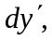the fraction of the amplitude of 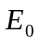 that gets through is 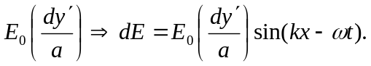
b) The path difference between each little piece is This can be rewritten as
c) So the total amplitude is given by the integral over the slit of the above.
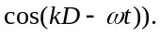
But the second term integrates to zero, so we have:
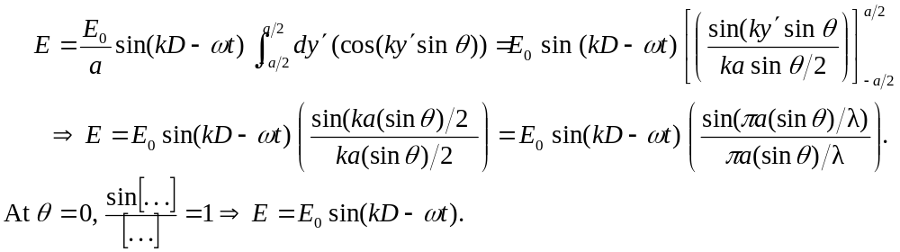
d) Since 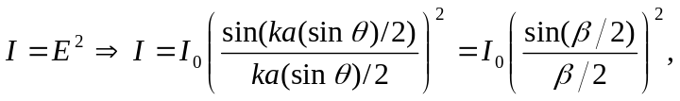 where we have used 